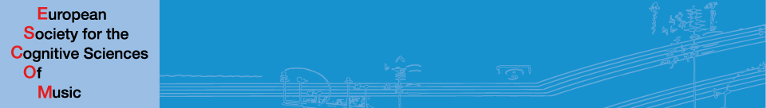
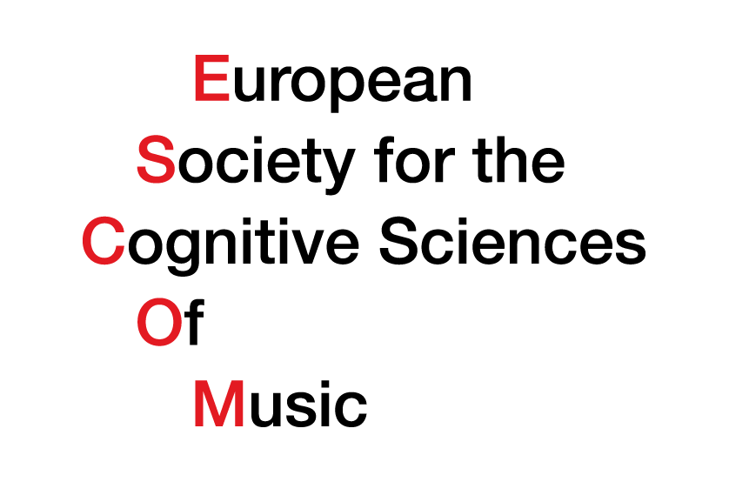
ESCOM

ESCOM is an international non-profit society to promote theoretical, experimental and applied research in the cognitive sciences of music. Since its foundation in 1991, ESCOM has become the leading European representative of scientific and interdisciplinary approaches to music. The society promotes collaboration among arts, humanities, and sciences; evaluation and dissemination of research findings; and activities of regional societies.

The Society launched its journal MUSICÆ SCIENTIÆ in 1997. Since 2011, the journal has been published by SAGE, assuring wide distribution and excellent online accessibility. The journal includes empirical, theoretical, and critical articles that address how music is perceived, represented, and generated from diverse disciplinary viewpoints. Issue topics have included the developmental psychology of music, musical creativity, similarity perception and modelling, music and evolution, music as emotion regulation, singing skills, and the perception of structure and form.

ESCOM organizes a major international conference every three years. Every six years, the conference is combined with the International Conference on Music Perception and Cognition (ICMPC). We also organise or support smaller conferences, symposia, educational programs, and summer schools.

Since 2010, ESCOM has been editing a series of "Classic European Music Science Monographs": English translations of seminal historic treatises in systematic musicology. Translations are funded by the Irène Deliège Translation Fund. The first volume in the series, Carl Stumpf's The Origins of Music, appeared in 2012.

ESCOM is entirely funded by membership fees and journal sales. We depend on the goodwill and support of researchers in music cognition to promote the discipline and continue its activities. Researchers at all career stages are encouraged to become members. Benefits include the journal (paper and electronic), academic networking, the right to vote and hold office, society discounts, and information about coming events.

Info: www.escom.org
Contact: escom@escom.org

